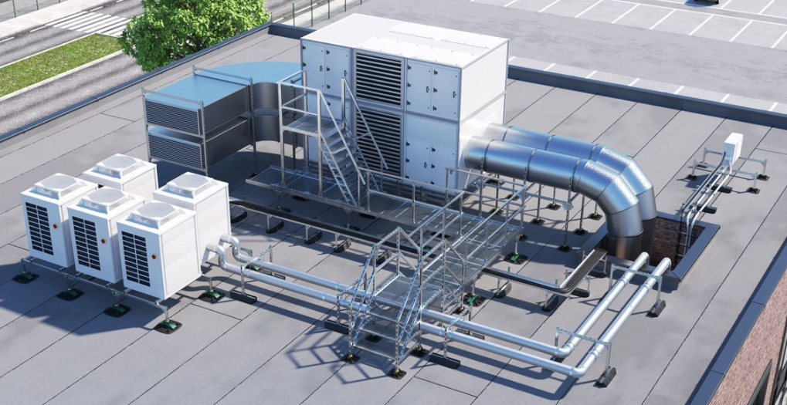
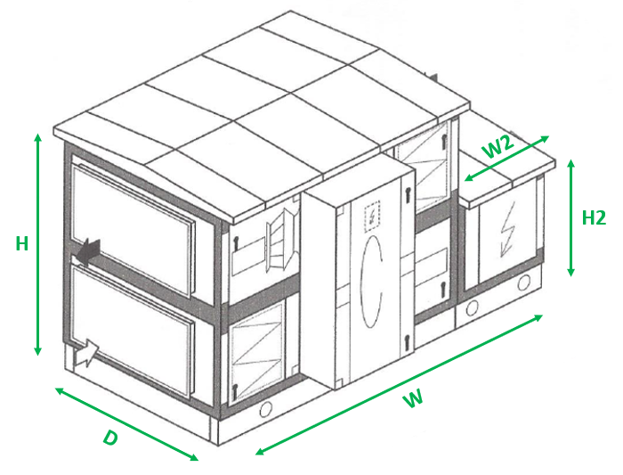

*Essential information

Rooftop details for solution finder
Unit NO. | Dimensions*  (HxWxD) | Additional dimensions*  (H2xW2xD) | Weight of unit*  (Kg or KN) | Height required from roof  (M) | Maximum allowed pressure on roof*  (kPa / kN/m²) | Location within the UK
Unit 1 | H :  D :  W: | H :  D :  W:
Unit 2 | H :  D :  W: | H :  D :  W:
Unit 3 | H :  D :  W: | H :  D :  W:
Unit 4 | H :  D :  W: | H :  D :  W:

